Contents
Understanding the Windows Azure Fabric Controller 2
Datacenter Resource Allocation 2
Deploying a Service 3
Datacenter Resource Provisioning 4
Service Lifecycle Management 5
Service Health Management 6
Node Health Index and FC 6

Understanding the Windows Azure Fabric Controller
The Fabric Controller (FC) is the “kernel” of the distributed operating system, called the Cloud operating system. The FC manages Windows Azure services and datacenter hardware.
The FC takes as inputs a description of the datacenter hardware and network resources it will control. The FC also accepts the service package and data, or binaries, from hosted cloud services.
The FC has 4 primary responsibilities shown below:
1. Provides datacenter resource allocation
2. Provides datacenter resource provisioning
3. Provides service lifecycle management
4. Provides service health management

Datacenter Resource Allocation
The Fabric Controller is an application running on server blades or nodes. It is capable of remembering application process states and is said to be stateful. The application is spread across fault domains effecting high system availability. See the diagram below.
The FC is initially installed on the Utility servers and other instances are installed from there.

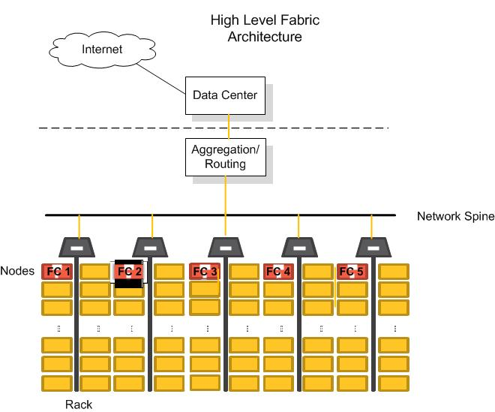

Deploying a Service
The Fabric Controller allocates resources needed to run a hosted service application amongst the compute, storage, and SQL Azure server resources.
The use of different roles by the hosted service application requires different Azure core resources.
For example, an application which calculates a return on investment would use one or more worker roles to perform the calculations. The worker role(s) require computing resources. The FC would assign these roles to compute server resources.
The goals for resource allocation are below.
• Allocate hosted service components to available resources while satisfying the constraints of hardware requirements
• Satisfy constraints of fault domains and update them to provide high availability and resiliency.
- Simplify host OS servicing and reduce processing time by selecting role instances in the same domain.

The process the FC uses to deploy a hosted service is as follows.

1. Allocate hardware and network resources
2. Prepare nodes, as discussed in Data Center Resource Provisioning
3. Configure networks.
• Dynamic IP (DIPs) addresses are assigned to blades.
• Virtual IP (VIPs) addresses and ports are allocated in the aggregation layer and mapped to sets of DIPs.
• The system is configured to allow traffic based on IP addresses.
Every hosted service has a Virtual IP (VIP) Address seen by the outside world. This VIP maps to a Dynamic IP address (DIP) for a specific role instance.

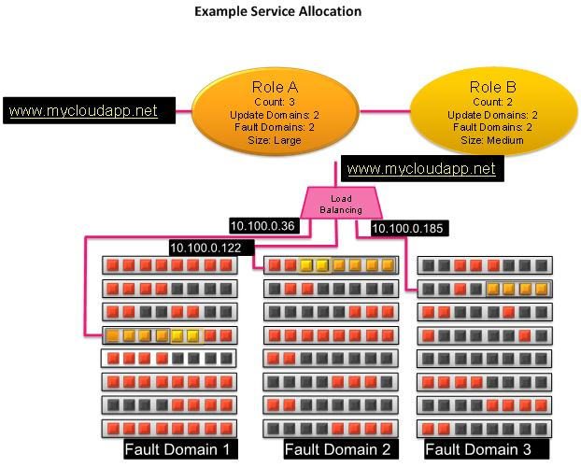

Datacenter Resource Provisioning
A node is a blade server. The Fabric Controller provisions or powers on nodes in the following process:
1. An FC agent starts a maintenance operating system (OS), using a Pre-Boot Execution Environment (PXE). The maintenance OS is taken from an image repository which also houses the parent FC OS and images of the service application roles that are in use.
2. An FC agent formats a Virtual Hard Drive (VHD) and downloads a host OS.
3. The host OS runs Sysprep/specialize, and reboots.
4. The Fabric Controller connects with the host agent.
5. The result, internal to the node, is a typical VM architecture, with a guest partition, all of the role instances, and guest agents, a trust boundary, and a host partition containing a trusted FC host agent. The trusted host agent allows communication to the primary FC, which then communicates with the replica FCs.
See the diagram below.

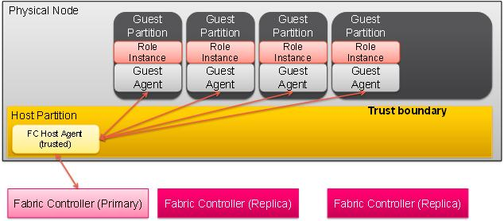

Service Lifecycle Management
In order to maintain high availability, the Fabric Controller is installed in at least 5 places, called Fault Domains. A Fault Domain is a set of computers, switches, and other devices that share a single point of failure. The system is designed so that a single piece of hardware cannot stop an entire application.
The FC instances communicate with each other so that they all keep in sync.
The FC multi-instance synchronization feature supports rolling upgrades to the fabric, allowing hosted services to continue to run in the event an FC becomes inoperative.
Multi-instance synchronization makes it possible to change, remove, and replace an instance while the system is running without degradation of services or data. Rolling upgrades and replacements of hardware and software are possible, due to multi-instance synchronization.

Service Health Management
The FC maintains service health by monitoring the heartbeats of roles and nodes.
The FC programs load balancers to probe a guest agent (GA) every 15 seconds. A “get” command is sent to the guest agent through its assigned virtual IP address. If the guest agent misses 2 probes, the load balancer stops forwarding traffic.
If the role reports a status of “busy” to the guest agent, the GA stops responding to probes.

Node Health Index and FC
The node health index algorithm is based on heartbeats and timeouts. The minimum time possible to detect a problem is equal to the sum of the heartbeat, plus the health timeout.
When the node health index falls below zero, the FC attempts to heal the node.
The table below shows some examples of how the fabric controller responds when a problem is detected.

